Laser Cutter Tutorials for GS Students

Hardware Overview
  - Vendor: Boss Laser, Florida. https://www.bosslaser.com/
  - Model: LS-1630. https://www.bosslaser.com/boss-ls-1630.html
  - Laser: Class 4 100-Watt CO₂ laser (bigger than most non-professional cutters)
    - The Art Department as a 150-Watt laser cutter than can cut metal.
  - Cost: ~$9500
  - Lens replacement cost: $220
  - Cutting area: 740mm x 380mm (29” x 15”)

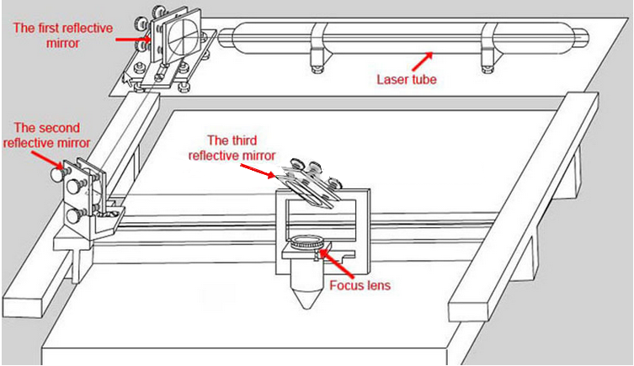

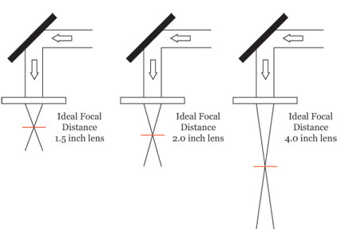
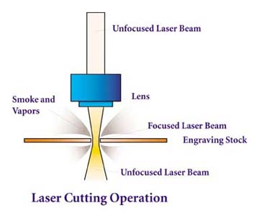

Materials Appropriate for Cutting
- See https://www.bosslaser.com/boss-ls-1630.html for a complete list
- Common materials are

    - Wood
    - Acrylic
    - Leather
    - MDF
    - Cardboard
    - Paper
    - Fabric
    - Vinyl (think: T-shirt design)
    - Fiberglass
    - Foam
    - Cork
    - Rubber (think: stamps)
    - Plastics (no PVC or chlorine-based products)

Materials Appropriate for Etching
- Same as above in addition to:

    - Phenolic
    - Melamine
    - Glass
    - Granite
    - Marble
    - Tile
    - Stone
    - Metals

Demo #1: Pulse Test with LS-1630 Console
- Moving the laser head
- Auto Focusing
- Laser pulse in focus
- Laser pulse out of focus (too close x1, too far x2)

Safety Considerations
- A Class 4, 100-W laser is dangerous, so good alignment with mirrors is critical. (Fortunately, Boss Laser aligns it before it is shipped.)
- The laser will not fire unless the lid is closed. (See magnetic sensor.)
- Fire hazards.
  - No fires yet, but pressed STOP a few times when nervous.
  - Squirt bottle at the ready for small mishaps, fire extinguisher for larger ones. (A last resort.)
  - Do not leave the cutter during a job!
- Ventilation is important. Even so, must not use PVC or chlorine-based products.

Physics behind the Laser cutter (info for experimentation)
- 2” (50mm) lens shipped with the LS-1630.
- Shipped 3” (75mm) replacement lenses by mistake.
- The thicker the material, the more you will need to adjust the focal depth.

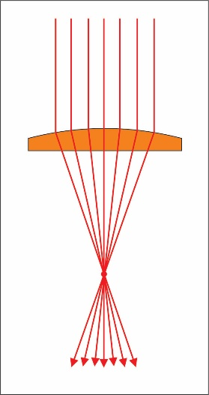
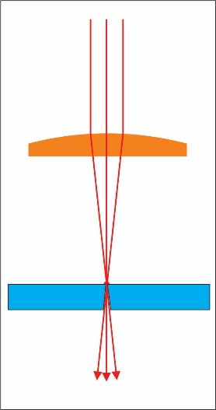

Software
- RDWorks (a.k.a LaserWORKS)
  - Communicates with Boss Laser via USB cable or flash drive
  - Not great for intricate design work; good for simple projects and image works
  - Installation (Mac users must use computer from laptop cart):
    - GS Laptop:
      - File Explorer >> View >> Place check in “File name extensions” box
      - File Explorer >> This PC >> OSDisk (C:) >> RDWorks:
        - Right-click on “RDWorks.exe” and select “Pin to Taskbar”
      - Open software from the Taskbar
    - Student PC:
      - Download LaserWORKS (Windows only): https://www.bosslaser.com/laser-software/
  - Set up RDWorks:
    - Config >> System Setting >> Laser Head: Dot in upper left corner
    - Config >> Page Setting
      - Page Width = 740 mm
      - Page Height = 380 mm
      - GridSpace = 25 mm
    - Config >> System Setting >> Graph Hatch
    - View: Check all options except the last three
    - Work Settings see “Cutting specs for LS1630 at GS.pdf” sheet (also in Canvas Files)

- eMachineShop 2D CAD Software:
  - Easy to use 2D CAD program, especially powerful gear wizard
  - Installation (Mac users must use computer from laptop cart):
    - GS Laptop:
      - In search bar, enter “eMachineShop”
      - Right-click on icon and select “Pin to Taskbar”
      - Open software from the Taskbar
    - Student PC:
      - Download (Windows only): https://www.emachineshop.com/free-download/
  - Set up eMachineShop:
    - On first run, check “Don’t show this message again” in lower right corner, and then press leftmost option: “New Drawing”
    - Edit >> Preferences:
      - Measurements Tab:
        - Select Millimeters, Degrees, and 2 decimal places
      - Grid Tab:
        - Check “Show Grid” box
        - Distance between grid points = 25 mm
        - Grid size:
          - Check “Limit grid to” box
          - Vertical = 380 mm
          - Horizontal = 740 mm
      - 2D Tab:
        - Add check to “Preserve arcs during stretching” box
  - Awesome eMachineShop Tutorials:
    - https://www.emachineshop.com/video-tutorials/

Etching and Cutting
- Etching is called “scanning” in RDWorks.
  - The higher the laser power and the slower the laser speed, the darker the image and the deeper the burn.
  - Experimentation is required and is a lot of fun getting to know the laser! Too fast and too little power, the laser will not make it through. Too slow and too much power, the wood will burn.

Demo #2: Practice Etching and Cutting Shapes and Text with RDWorks
- Wood: ¼” Lauan (Sande)
- Lens: 75mm
- Students follow along all steps:
  - Enter text with these parameters:
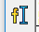
    - Font: Stencil
    - Text: “HELLO”
    - Height: 15mm
    - Width: 75%
  - Set text to Blue Layer:
    - Set to Scan Mode. Speed: 300mm/s. Power: 35%. Interval: 0.1.
  - Draw a rectangle of these dimensions:
    - 52mm x 27mm
  - Set rectangle to Red Layer:
    - Set to Cut Mode. Speed: 20mm/s. Power: 50%.
    - Uncheck “Laser through mode” box
  - Draw a circle of diameter:
    - 5mm
  - Set circle to Green Layer:
    - Set to Cut Mode. Speed: 20mm/s. Power: 50%.
    - Uncheck “Laser through mode” box
  - Align all the objects so they are centered, with low text and high circle. Use buttons:
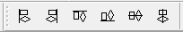

- Double-check speed and power settings.
- Order the layers -- this is important! You must cut the square last!
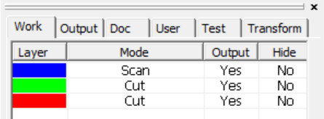

- Preview to ensure the cuts are done in right order!
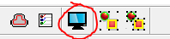

- Move computer to the Laser Cutter and connect via the USB cable.
- Turn on laser cutter.
- Download file to the laser cutter via Download Button in RDWorks.
- Position the laser head to the green box position. (This position can be changed.)
- Set origin and fame the piece. Always frame it!
- Turn on the compressor, exhaust fan, and chiller!
- Focus the machine and laze it!

Student Project: Create a Nameplate for Shelf using eMachineShop and RDWorks
- Wood: ¼” Lauan (Sande)
- Lens: 75mm
- Use a Vernier caliper to measure the width the cable tie that will be used to hold the nameplate to the shelf. Record that width here: _________________ mm.

- Design nameplate using eMachineShop:
  - The maximum dimensions are 150mm x 25mm! Stay within these parameters!
  - Use the Rectangle tool to draw a box with your rough desired dimensions.
  - Use the Circle tool to add two circles that the cable ties will be inserted into. You decide on the proper size.
  - Place the circles on the corner of the box using the snap-to handles:

  - Click on one of the circles and set the Nudge Step value to something reasonable:
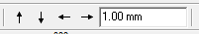

  - Use the Nudge Arrows to move each circle so that they are symmetrically spaced and near the top of the box. (You may wish to change the nudge values as you do this.)

  - Enter your name using the Text tool:
    - Select the tool and click on the build surface.
    - Enter your First and Last name. (If your name is long, you may want to use only your first or only your last name.):
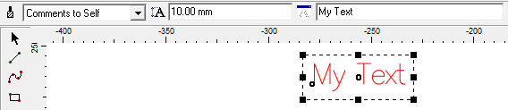

    - Change font from “Comments to Self” to “Auto”:
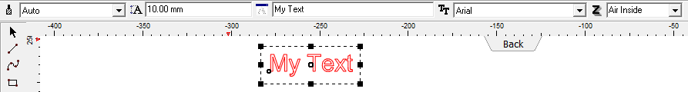

- Choose your font. (This is easiest if you just select a font near the top of the list, and then use the arrow keys on the keyboard to scroll down through the list.)
  - Caution: if the font is too complex or fancy, it may not export well or at all. It doesn’t have to be plain “Arial”, but something like “Curlz MT” may not export well!
- Resize name so that it fits in the box without getting too close to the edge and the circles.
- You might need/want to resize your box and move your circles to make everything fit and look nice. Just remember to stay within the maximum dimensions and keep the circles evenly spaced and symmetrical.
- No matter which font you used, your text will probably NOT export, because it is still text and not a line drawing. (You can still change the text at this point.)

- To make a clean exportable text, you must first ungroup the text by right-clicking on the text and choosing “Ungroup” or pressing CTRL+U. (You can re-group the letters immediately (CTRL+G) if you want and probably should.) The text is now a drawing and is unable to be edited.
- Make sure that the Z is “air inside”:
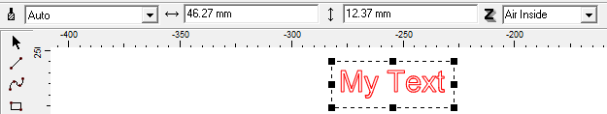

- You can make your box fancy by adding a curve to the corners! Try it:
  - Select your box.
  - Line >> Corner
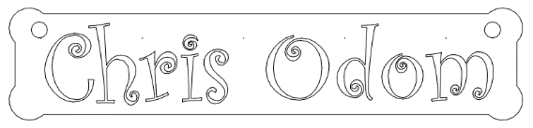
    - Select one of the options, which include Round, Mate, and Chamfer.
    - For this nameplate, change the radius and distance measures around 5mm to start.
    - Check the “Show preview” box.
- Highlight all of your work (the box, the circles, and the text) and select File >> Export:
  - Place a check in the “Selected only” box.
  - Name your DXF file and save it to your desired folder on OneDrive or another drive. Save it with your Arrangement number and your name, such as “Arr 8 Chris Odom”.
  - Make sure to save it with the DXF file type: “AutoCAD … DXF”.
- You are now ready to import the file into RDWorks to make it ready to be cut with the laser cutter!

- Import nameplate DXF file using RDWorks:
  - Open RDWorks
  - File >> Import and locate your DXF file that you created using eMachineShop.
  - Prepare the file for laser cutting as you were taught. Use the same etch and cut settings as above. Your name should be etched (scanned).
  - If some of the letters in your name do not fill with a color when changed to Scan mode, it means that there is break somewhere in the outline:
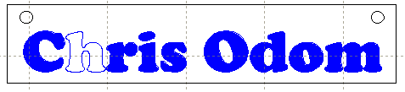

  - Make sure that you followed all the above steps to make your text clean and exportable. If the problem persists, do one or more of the following:
    - return to eMachineShop and make your text MUCH larger, export it to RDWorks again, and then shrink the text within RDWorks (small letters don’t export well),
    - or start over in eMachineShop with a simpler font,
    - or delete the text and simply use the Text tool within RDWorks to enter your name,
    - or ask your teacher for assistance to repair the letter. Quick notes for Chris and Brian:
      - Select offending letter with Select arrow.
      - Press Edit Node arrow.

      - Look around edge for obviously broken nodes.
      - If you don’t see one, select a node and press the Break Curve button. This will show you were the break is. (There may be multiple breaks.)
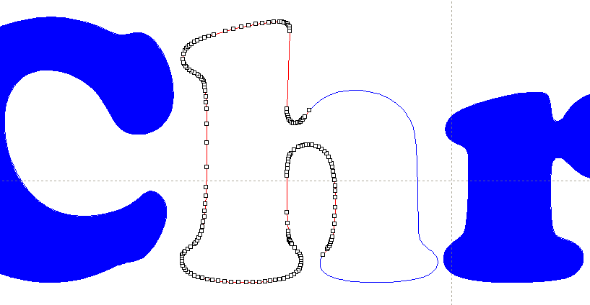
Deleted node with Break Curve button

Broken node is revealed!

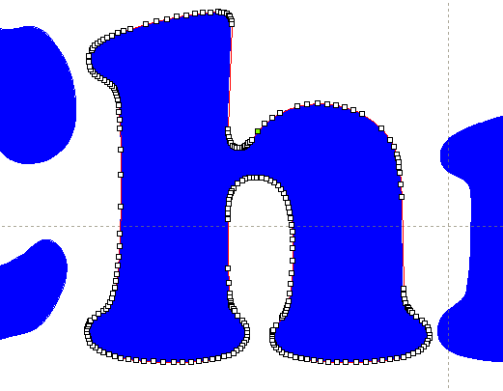
      - Clean up the break by deleting bad nodes and moving the two adjacent broken nodes nearby each other. Then highlight them and press the Combine Nodes button. If this is your only break, your letter will be filled with the scan color. If not, repeat the process and search for another break.

  - Make sure all your objects are aligned and the holes for the cable ties are well-placed.
  - Make sure that the speed and power settings for each layer are correct. See above tutorial for the proper values.
  - Make sure the layers are in the correct order -- this is important! You must cut the square last!

  - Preview to ensure the cuts are done in right order!

- Save your work and send it to your teacher
  - There are many ways to proceed from here and cut your nameplate, but for this assignment, simply save your RDWorks file and send it to your teacher.
    - Save your file RDWorks with a name that includes your arrangement and your name (for example, “Arr 8 Chris Odom”).
    - Save the RLD file to your desired folder on OneDrive or another drive.
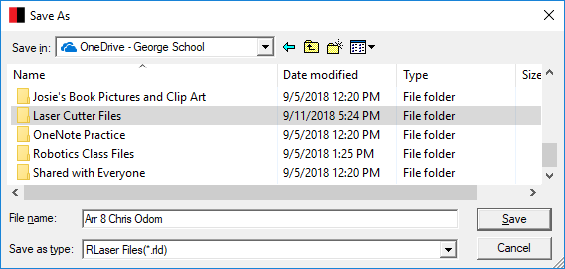

  - Upload your RLD file into Canvas via the assignment.

- Laser that sucker!

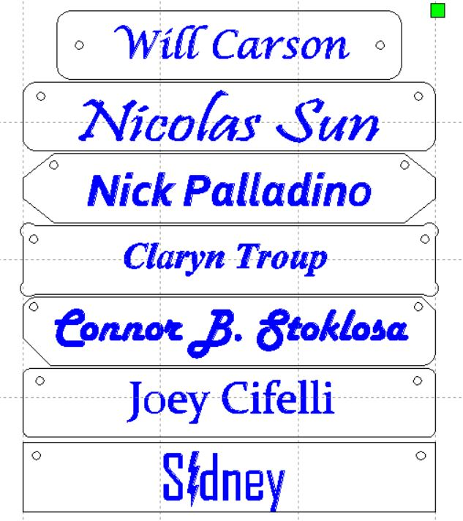
- Here are some student nameplate examples:

